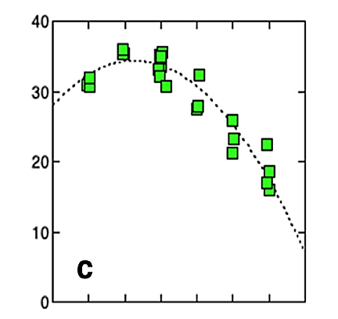

Leaf temperature (oC)

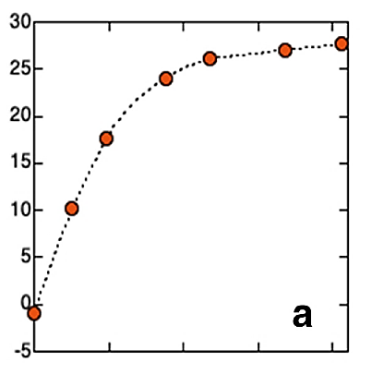

Light intensity (µmol/m2/s)

Photosynthesis rate

*(CO2 absorption in µmol/m2/s)*

Photosynthesis rate

*(CO2 absorption in µmol/m2/s)*

The data above is from a larger study into the measurable factors which can influence photosynthesis as measured by CO2 absorption by a leaf. The paper “*Linking remote sensing parameters to CO2 assimilation rates at a leaf scale*” was authored by Kouki Hikosaka and Katsuto Tsujimoto, and published in March 2021 in the Journal of Plant Research (a peer reviewed journal)

The graph on the left investigated the effect of leaf temperature on the rate of photosynthesis, while the graph on the right investigated the effect of light intensity hitting the leaf on the rate of photosynthesis.



Leaf temperature (oC)



Light intensity (µmol/m2/s)

Photosynthesis rate

*(CO2 absorption in µmol/m2/s)*

Photosynthesis rate

*(CO2 absorption in µmol/m2/s)*

The data above is from a larger study into the measurable factors which can influence photosynthesis as measured by CO2 absorption by a leaf. The paper “*Linking remote sensing parameters to CO2 assimilation rates at a leaf scale*” was authored by Kouki Hikosaka and Katsuto Tsujimoto, and published in March 2021 in the Journal of Plant Research (a peer reviewed journal)

The graph on the left investigated the effect of leaf temperature on the rate of photosynthesis, while the graph on the right investigated the effect of light intensity hitting the leaf on the rate of photosynthesis.